Name

Mathematics Advanced Year 11
Data

Book 1 |  | Version: 250928  Feedback:  https://MrDingMaths.com
Contents
Syllabus Content 2
Random Variables 3
Organising Discrete Random Variables 6
Summary Statistics from Tables and Graphs 10
Relative Frequency and the Law of Large Numbers 14

Syllabus Content
MAV-11-10 displays and analyses datasets using summary statistics and graphical representations
Data
- Define a random variable as a variable whose value is the outcome of a random experiment
- Compare discrete random variables with continuous random variables, describe their differences, and give practical examples of each
- Organise finite datasets using a table or a spreadsheet, listing the values, frequency, relative frequency, cumulative frequency, and cumulative relative frequency
- Graph the frequency, relative frequency, and cumulative frequency histograms and polygons of datasets, using spreadsheets or graphing applications, and identify the mode and median from the graphs, and from tables
- Use the relative frequency to estimate the probability of results in experiments

Random Variables

- Random Variables
Data has variables and values.
- A variable is anything we can describe, measure, or count.
- Data values are the measurements.
Variables | Data Values
Age | 11, 12, 15, 21, 86
Grade | A, B, C, D, E
Colour | Red, Green, Orange

A random variable, $X$, is a variable whose values $x$ are outcomes of a random process.
The outcomes of a random variable are always numbers.
Random Variable $X$ | Data Values / Outcomes $x$
Number rolled on a standard die. | {0, 1, 2, 3, 4, 5, 6}
Number of heads when tossing a coin three times. | {0, 1, 2, 3}
Height of a Year 7 student in  Mr Ding’s class, in cm. | {$120<x<155$}

- Interpret a random variable and its values.
List the set of possible outcomes for each random variable.
- $X$: The number rolled on a four-sided die.  $X=\{$ | - $X$: The number of girls in a group of 3 children.  $X=\{$
- $X$: The number of heads when tossing a coin five times. | - $X$: The sum rolled on a pair of dice.
- $X$: The number of tails when tossing a coin six times. | - $X$: The number of red marbles in a bag of four marbles.
- Discrete and Continuous Random Variables
Discrete | Continuous
Values that increase in steps.  Usually the result of counting.  You can list all possibilities. | Values with no gaps between them, and can take any value within a range.  Usually the result of measuring,  You cannot list all possibilities.
Goals scored: {0, 1, 2, 3 … }  Cars in car park: {0, 1, 2, … }  Students enrolled in a class: {22, 23, … } | Height of students {165.3, 170.88, 172.2825}  Time to run 100m: {12.4s, 13.7s, 15.255s}  Temperature: {23.4°C, 25.85°C, 19.11°C}

- We will focus on discrete random variables for now.

- Distinguish between discrete and continuous random variables.
- Number of goals scored by a netball team | - Height of a student
- Shoe size of a Year 11 student | - Number rolled on a 6-sided die
- Number of tails when flipping a coin 50 times. | - Number of oranges on a tree
- Daily rainfall in Sydney during September | - Speed of cars on a motorway
- Temperature of a metal bar as it cools | - A film critic’s rating of films, from 0 to 4 stars
- The sum rolled on a pair of dice | - Weight of parcels delivered by the post office
- Number of cars passing the school over 10 minutes | - Number of cities with more than 100,000 population in European countries

Foundation
- For each random variable, state whether it is discrete or continuous.
- A film critic rates a film from 0 to 4 stars.  Discrete | - A car's speed.  Continuous
  - Discrete | - Continuous
  - Discrete | - Continuous
- The sum you roll on a pair of dice.  Discrete | - The winning ticket number drawn from a raffle.  Discrete
  - Discrete | - Continuous
  - Discrete | - Continuous
- Parcels' weight at a post office.  Continuous | - Jean sizes in a shop.  Discrete
  - Discrete | - Continuous
  - Discrete | - Continuous
- A metal's temperature as it cools.  Continuous | - The amount of water in different types of fruit drink.  Continuous
  - Discrete | - Continuous
  - Discrete | - Continuous
- Cars passing the school over a 10-minute period.  Discrete | - Cities in each European country.  Discrete
  - Discrete | - Continuous
  - Discrete | - Continuous
- Heads when you toss a coin 50 times.  Discrete | - Correct answers in a 10-question test.  Discrete
  - Discrete | - Continuous
  - Discrete | - Continuous

- Write the set of possible values for each discrete random variable.
  - $X$: Daughters in a two-child family.
$X$ = {0, 1, 2}
  - $X$: Number of 6s on 5 rolls of a die.
$X$ = {0, 1, 2, 3, 4, 5}
  - $X$: People aged over 50 in a group of 10 people.
$X$ = {0, 1, 2, 3, 4, 5, 6, 7, 8, 9, 10}
  - $X$: Days it rains in a week.
$X$ = {0, 1, 2, 3, 4, 5, 6, 7}
  - $X$: The sum of 2 numbers rolled on a pair of dice.
$X$ = {2, 3, 4, 5, 6, 7, 8, 9, 10, 11, 12}
  - $X$: Tails when flipping 3 coins.
$X$ = {0, 1, 2, 3}
  - $X$: Number of red cards when drawing 5 cards from a standard deck.
$X$ = {0, 1, 2, 3, 4, 5}
  - $X$: Number of Aces when drawing 5 cards from a standard deck.
$X$ = {0, 1, 2, 3, 4}
  - $X$: Number of letters in a word randomly chosen from this sentence.
$X$ = {1, 2, 4, 6, 7, 8}
  - $X$: A digit randomly chosen from the number 3.141592653.
$X$ = {1, 2, 3, 4, 5, 6, 9}

Organising Discrete Random Variables

- Frequency Tables and Histograms
Frequency is how often a data value occurs.
A frequency histogram is a special type of column graph with no gaps between columns.
A frequency polygon is a line graph that connects the centres of the columns to the $x$-axis.
Frequency Table | Frequency Histogram | 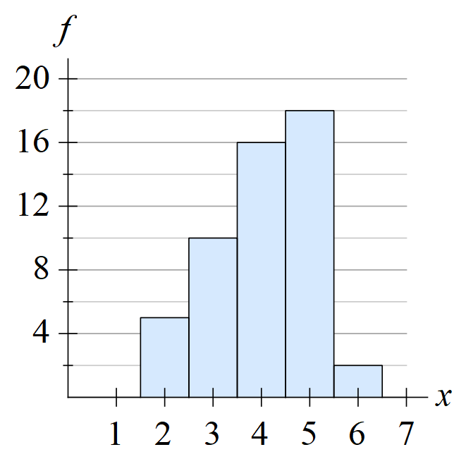  Frequency Polygon  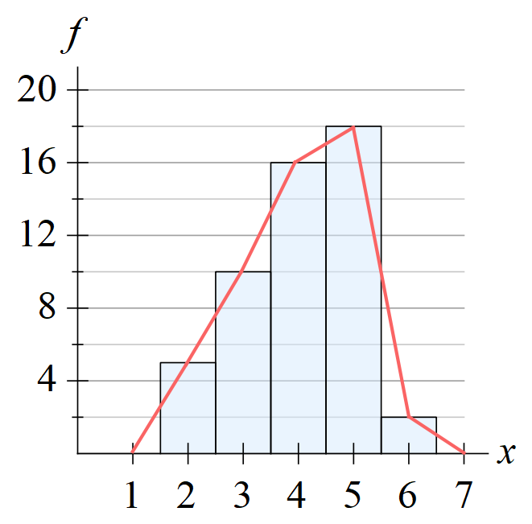
  Data value $x$ | Frequency  $$f$$
  2 | 5
  3 | 10
  4 | 16
  5 | 18
  6 | 2

- Sketch Frequency histogram from table.
Sketch the frequency histogram from the frequency table.
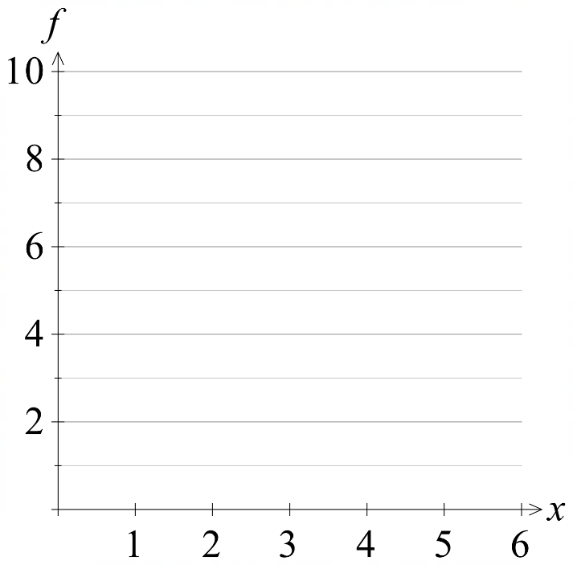 | 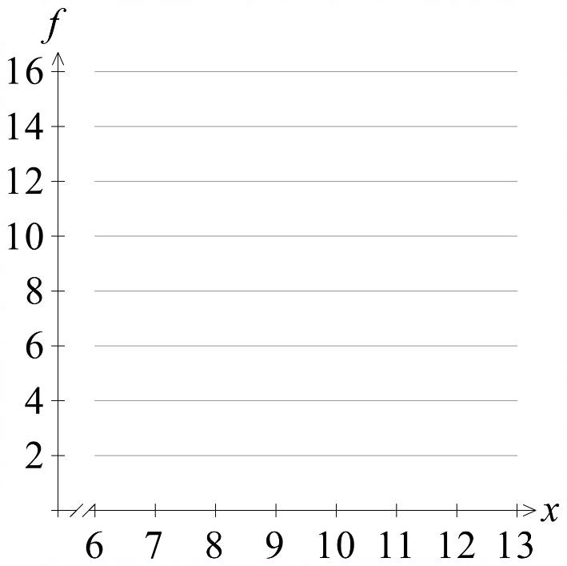
  $$x$$ | $$f$$
  1 | 6
  2 | 8
  3 | 0
  4 | 9
  5 | 2
  $$x$$ | $$f$$
  7 | 3
  8 | 3
  9 | 11
  10 | 11
  11 | 6
  12 | 14

- Sketch Frequency polygon from histogram.
Sketch the frequency polygon using the given histogram.
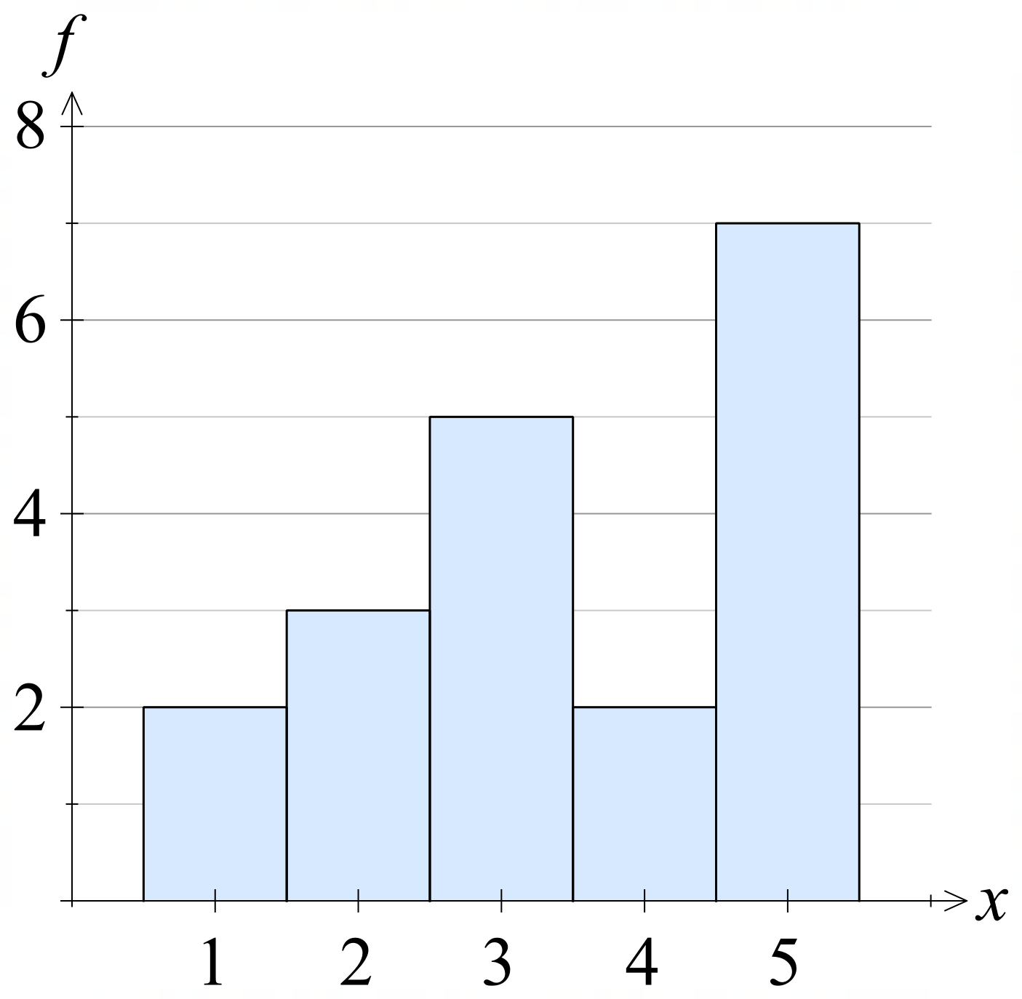
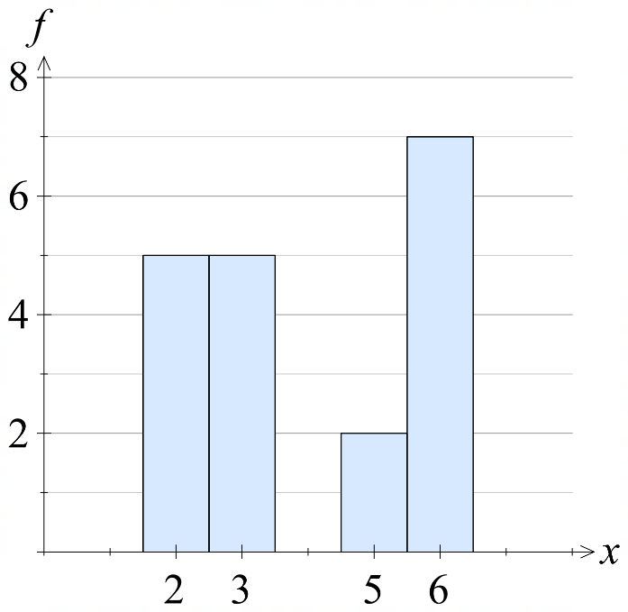

- Example Organise datasets using a frequency table.
Consider the following dataset: 5, 5, 5, 6, 6, 7, 7, 7, 7, 8, 10, 10.
Organise the data into a frequency table, then graph the frequency histogram and polygon.
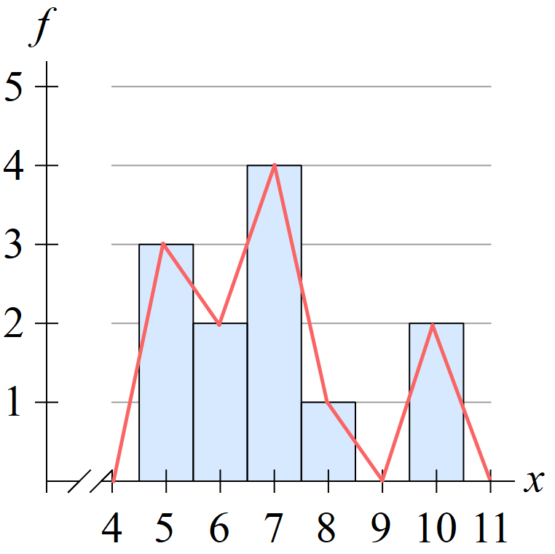
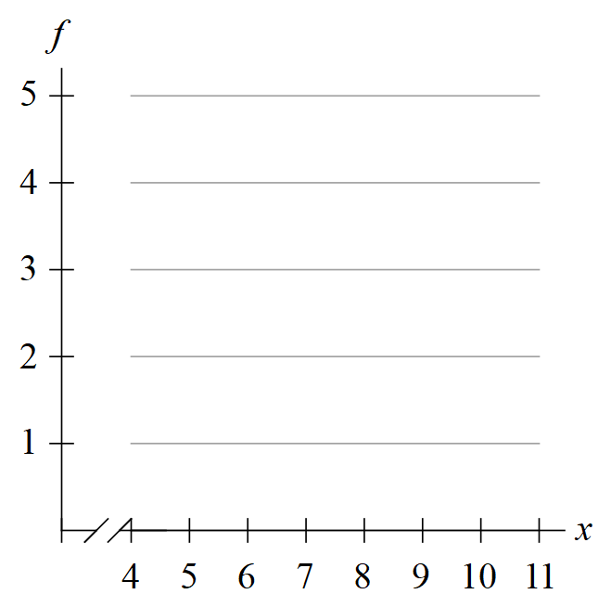
Data value $x$ | Frequency  $$f$$
5 | 3
6 | 2
7 | 4
8 | 1
9 | 0
10 | 2

- Practice
Consider the following dataset:
12, 12, 12, 12, 13, 14, 14, 15, 15, 15, 15, 15, 16, 16, 16, 16, 16
Organise the data into a frequency table, then graph the frequency histogram and polygon
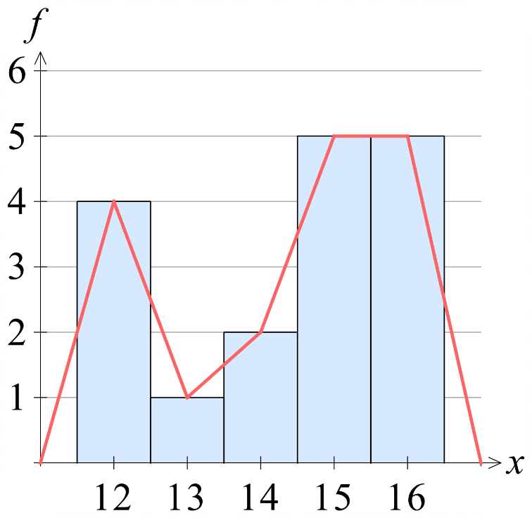
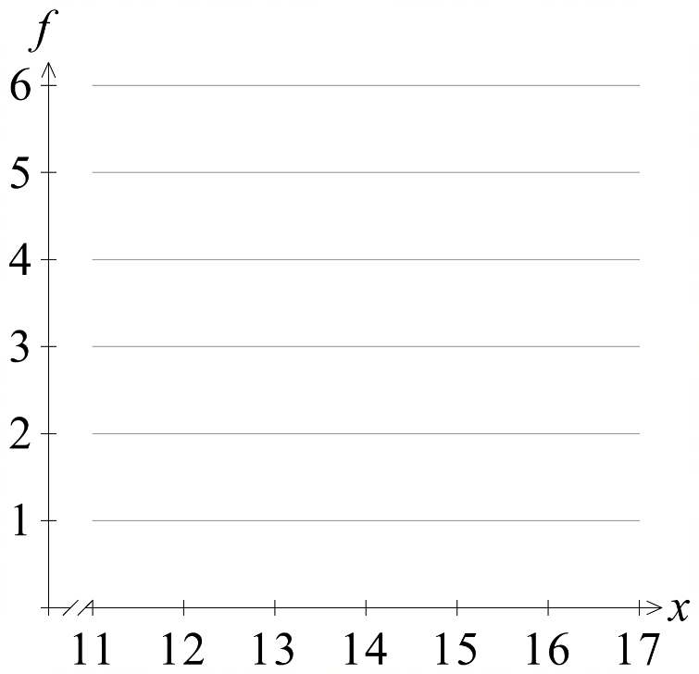
Data value $x$ | Frequency  $$f$$
12 | 4
13 | 1
14 | 2
15 | 5
16 | 5

- Cumulative Frequency Tables and Histograms
Cumulative Frequency is the total count of data values up to and including a value.
The final number in the cumulative frequency column always equals the total frequency of all data values.

- Example Calculate cumulative frequency and interpret data.
Several families were surveyed about how many children are in their family.
The results are shown in the frequency table.
- Find the cumulative frequency. | - How many families were surveyed?  25, the total frequency is the final value in the cumulative frequency column.  - How many families had 3 or fewer children?  19.  - How many families had fewer than 3 children?  12.
  Number of Children  $$x$$ | Frequency  $$f$$ | Cumulative Frequency  $$c.f.$$
  1 | 3 | 3
  2 | 9 | 12
  3 | 7 | 19
  4 | 4 | 23
  5 | 2 | 25

The table below shows the scores of a class of students in a quiz.
- Find the cumulative frequency. | - How many students in the class?  32  - How many students scored 6 or less?  10  - How many students scored 7 or less?  27  - How many students scored less than 8?  27
  Score  $$x$$ | Frequency  $$f$$ | Cum. Freq.  $$c.f.$$
  4 | 4 | 4
  5 | 6 | 10
  6 | 7 | 17
  7 | 10 | 27
  8 | 5 | 32
The table below shows the number of times an ambulance was called out in a day.
- Find the cumulative frequency. | - Over how many days was the survey conducted?  35  - On many days was the ambulance called out less than 23 times?  17  - On many days was the ambulance called out 23 times or less?  29
  Calls  $$x$$ | Frequency  $$f$$ | Cum. Freq.  $$c.f.$$
  20 | 4 | 4
  21 | 3 | 7
  22 | 10 | 17
  23 | 12 | 29
  24 | 6 | 35
- Cumulative Frequency Tables and Histograms
A cumulative frequency histogram is a histogram that graphs the cumulative frequency.
A cumulative frequency polygon, or ogive, is a line graph that connects the top-right corners of the columns.

- Example Organise datasets using a cumulative frequency table.
Consider the following English essay marks out of 10.
5, 5, 5, 6, 6, 7, 7, 7, 7, 8, 10, 10
Organise the data into a frequency table, then graph the frequency histogram and polygon.
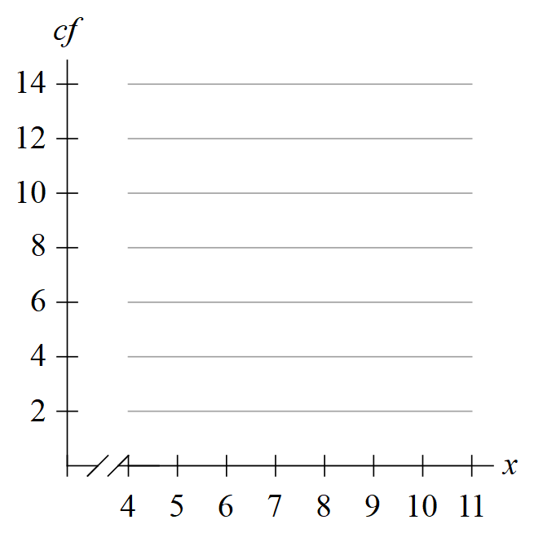
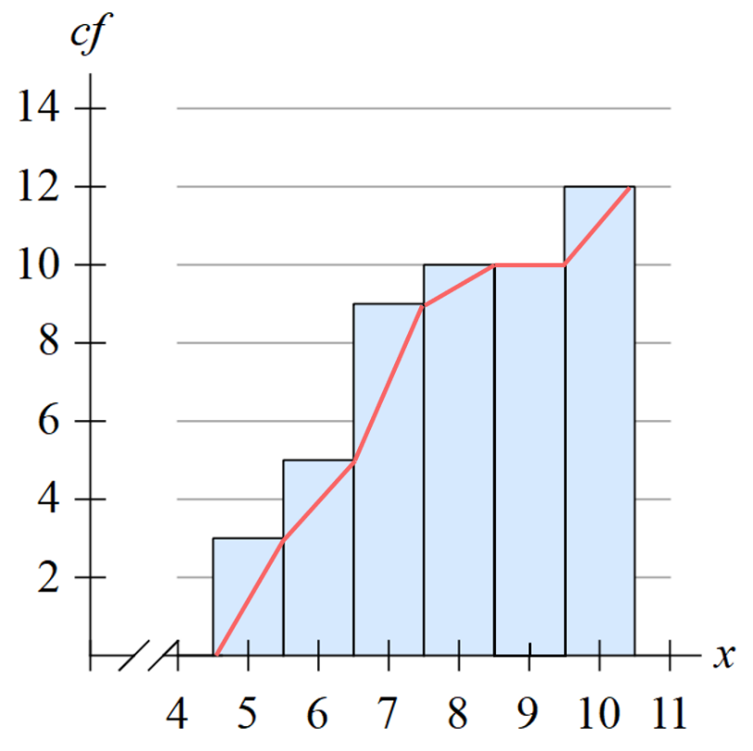
$$x$$ | $$f$$ | $$cf$$
5 | 3 | 3
6 | 2 | 5
7 | 4 | 9
8 | 1 | 10
9 | 0 | 10
10 | 2 | 12

- Practice
The maximum temperature, in $°C$ on each day in September is shown in the table.
Draw the cumulative frequency histogram and polygon.
$$x$$ | $$f$$ | $$c.f.$$
17 | 1 | 1
18 | 2 | 3
19 | 4 | 7
20 | 7 | 14
21 | 6 | 20
22 | 6 | 26
23 | 4 | 30
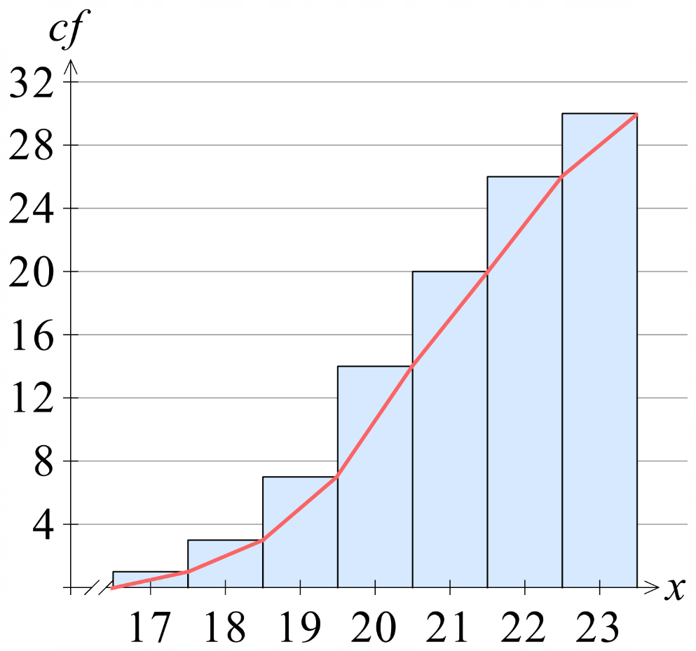
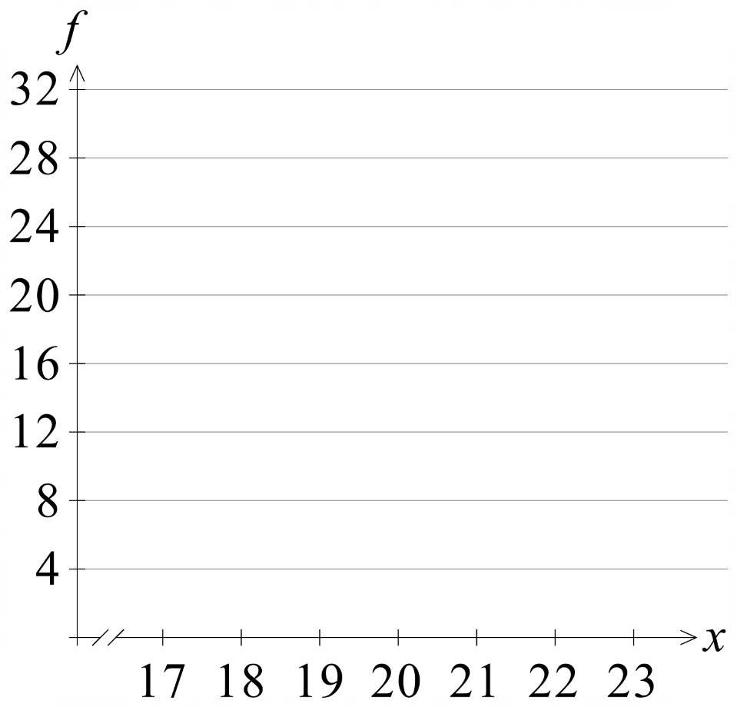

Summary Statistics from Tables and Graphs

- Mode from Tables and Histograms
The mode is the value that appears most often in a dataset.
- The mode is the data value, not the frequency.

- Identify Mode from tables and histograms.
  $$x$$ | $$f$$
  2 | 5
  3 | 10
  4 | 16
  5 | 18
  6 | 2
  $$x$$ | $$f$$
  1 | 2
  2 | 7
  3 | 2
  4 | 2
  5 | 2
  $$x$$ | $$f$$
  22 | 1
  23 | 10
  24 | 5
  25 | 3
  26 | 6
  $$x$$ | $$f$$
  22 | 1
  23 | 3
  24 | 5
  25 | 19
  26 | 6
  $$x$$ | $$f$$
  22 | 1
  23 | 12
  24 | 5
  25 | 12
  26 | 6
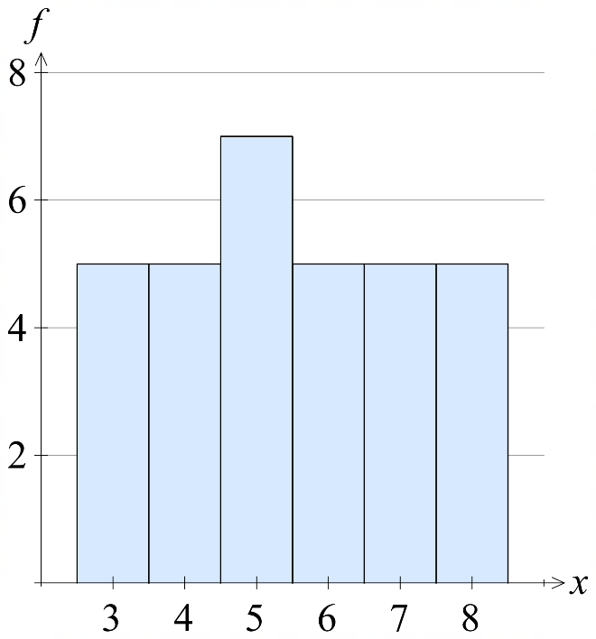 | 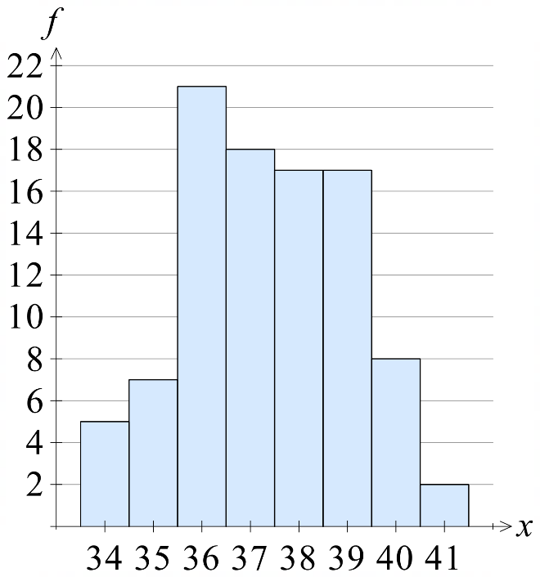 | 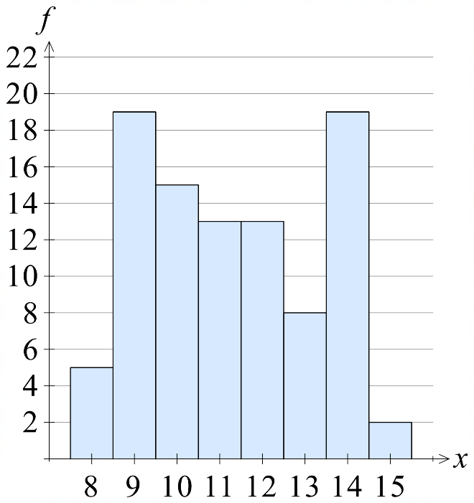

- Mean from Tables
The mean is the sum of all values divided by the number of values.
We use multiplication to quickly add many of the same value.
1. Create the $xf$column to calculate Data value $×$ Frequency.
2. Find $∑xf$ and $∑f$.
3. Formula: $\overline{x}=$ $\frac{∑xf}{∑f}$.

- Example Calculate mean from frequency tables.
1. $xf$ column  3.  $$\overline{x}=\frac{167}{12}=13.75$$ | For the table to the left, write out the entire dataset and find the mean by summing the data values.
  $$x$$ | $$f$$ | $$xf$$
  12 | 3 | 36
  13 | 2 | 26
  14 | 4 | 56
  15 | 1 | 15
  16 | 2 | 32
  2. | $Σf=$ 12 | $Σxf=$ 165

- Practice
1.23 | 2.57
  $$x$$ | $$f$$ | $$xf$$
  0 | 4
  1 | 3
  2 | 5
  3 | 1
   | $$Σf$$ | $$Σxf$$
  $x$ | $$f$$ | $$xf$$
  1 | 2
  2 | 4
  3 | 6
  4 | 2
   | $$Σf$$ | $Σxf$
5.86 | 12.56
  $$x$$ | $$f$$ | $$xf$$
  4 | 3
  5 | 2
  6 | 7
  7 | 0
  8 | 3
   | $Σf$ | $Σxf$
  $$x$$ | $$f$$
  11 | 3
  12 | 2
  13 | 0
  14 | 4
- Median from Tables
The median is the middle value in an ordered dataset.
For a table:
- Find the median position using $Mp=$ $\frac{n+1}{2}$
- The median is the value where cumulative frequency first equals or exceeds $Mp$.
- The median is not simply the middle number of the table column.

- Identify Median from tables.
$$1. Mp=\frac{12+1}{2}=6.5$$  2. $c.f.$ first exceeds 6.5 when $x=14$  The median is 14. | For the table to the left, write out the entire dataset and find the median by looking for the middle value.
  $$x$$ | $$f$$ | $$c.f.$$
  12 | 3 | 3
  13 | 2 | 5
  14 | 4 | 9
  15 | 1 | 10
  16 | 0 | 10
  17 | 2 | 12
  $$x$$ | $$f$$ | $$c.f.$$
  11 | 2 | 2
  12 | 2 | 4
  13 | 2 | 6
  14 | 7 | 13
  15 | 2 | 15
  $x$ | $$f$$ | $$c.f.$$
  11 | 7
  12 | 2
  13 | 2
  14 | 2
  15 | 2
  $$x$$ | $$f$$ | $$c.f.$$
  20 | 4
  21 | 3
  22 | 10
  23 | 12
  24 | 6
  $x$ | $$f$$
  17 | 1
  18 | 2
  19 | 4
  20 | 7
  21 | 6
  22 | 6

- Median from Histograms
The median is the middle value in an ordered dataset.
For a graph:
1. Find 50% of the total cumulative frequency.
2. Draw a horizontal line to the ogive, then read off the median.
For ungrouped data, the median is simply the number.
- The median is not simply the middle number on the axis.
- Find 50% of the highest column, not the largest axis value.

- Identify Median from cumulative histogram.
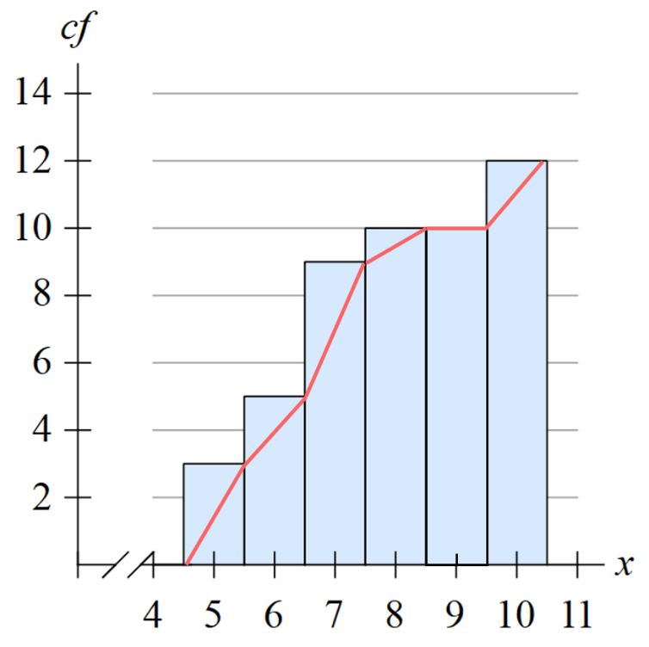 | 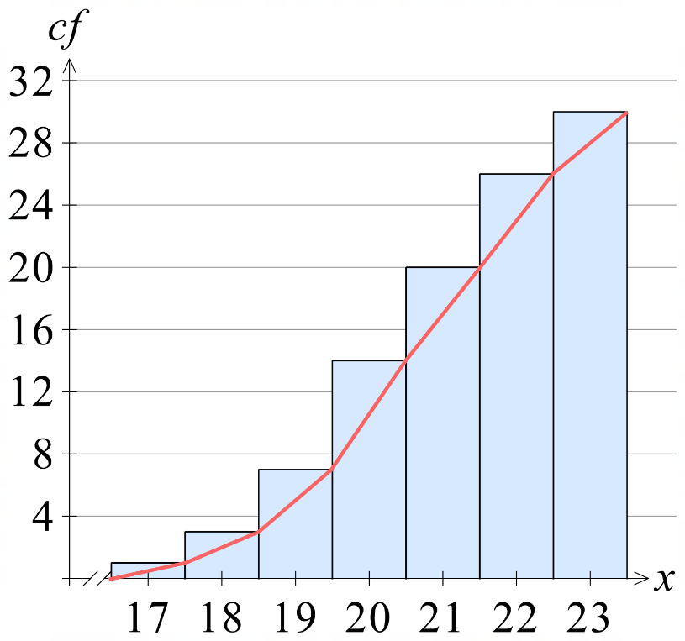
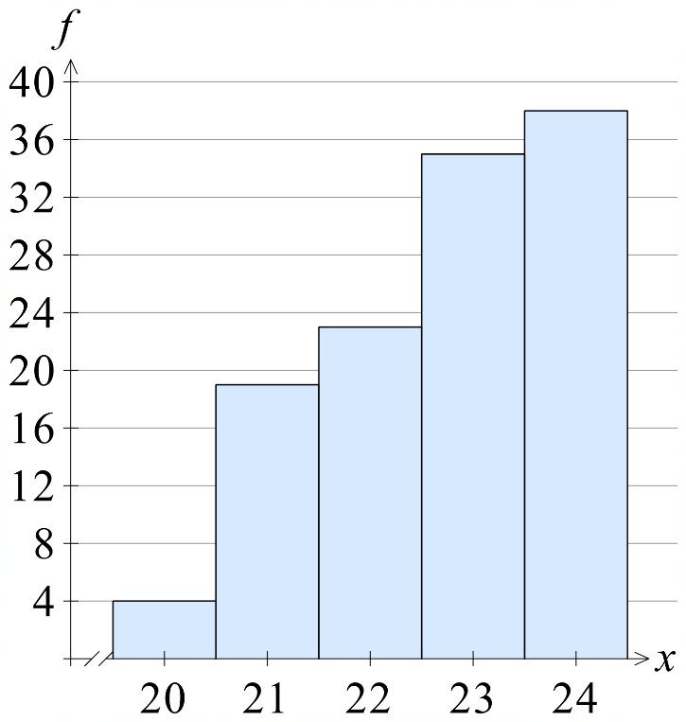 | 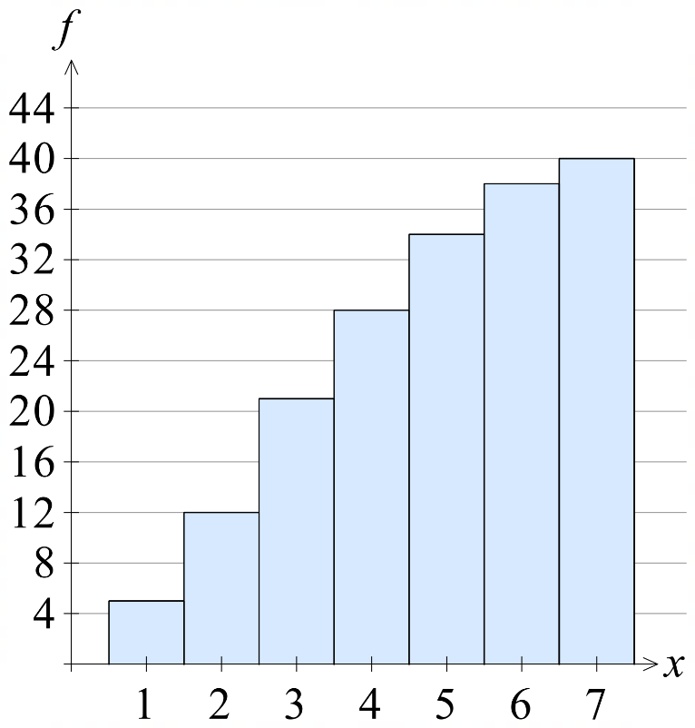
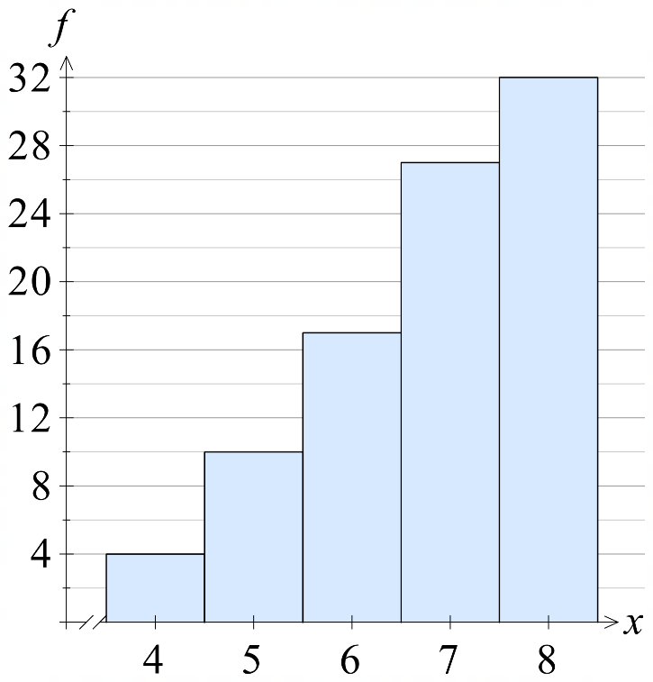 | 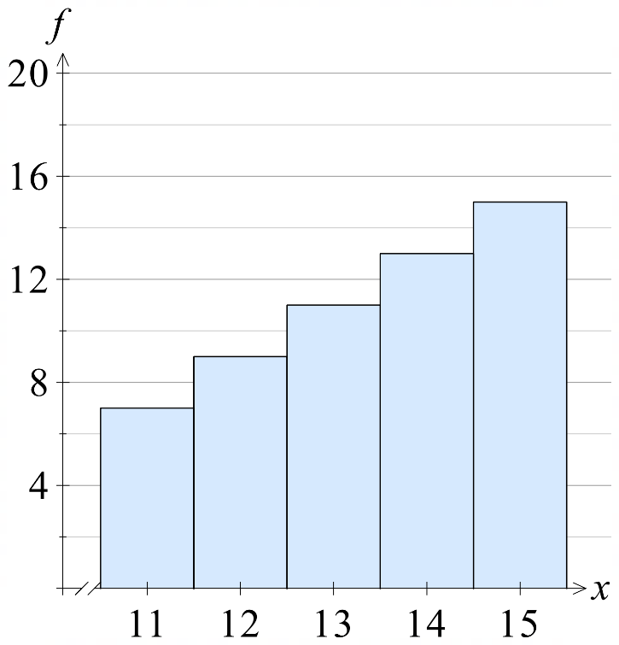

Relative Frequency and the Law of Large Numbers

- Relative Frequency
Relative frequency of an outcome is how often the outcome happens compared to the total number of trials.
$$\begin{matrix}Relative \\ frequency\end{matrix}=\frac{Frequency of outcome }{Total frequency}$$
- The relative frequency of all outcomes must add to 1.
- When graphing, it is a good idea to express relative frequency as a decimal.

- Example Calculate relative frequency and sketch the histogram.
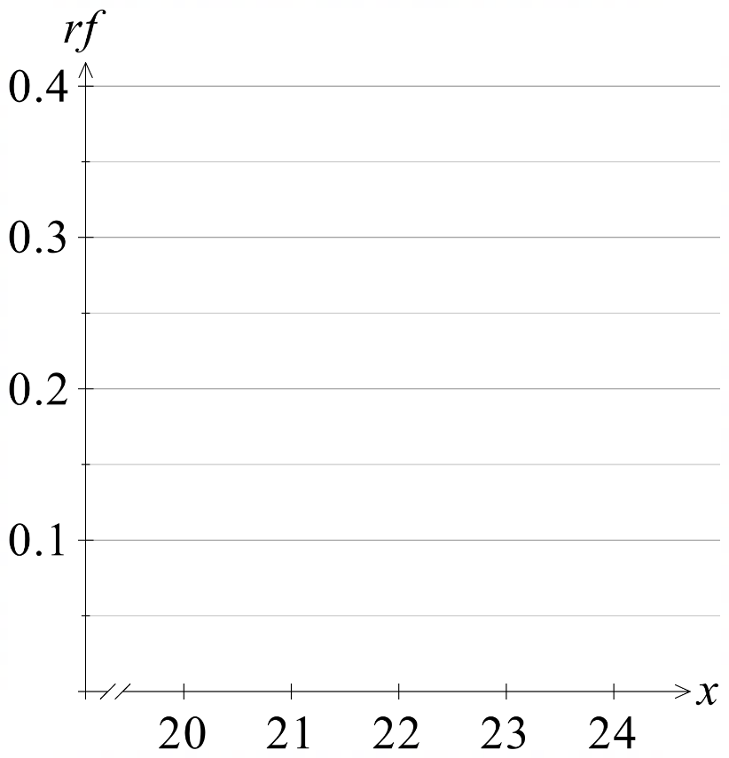
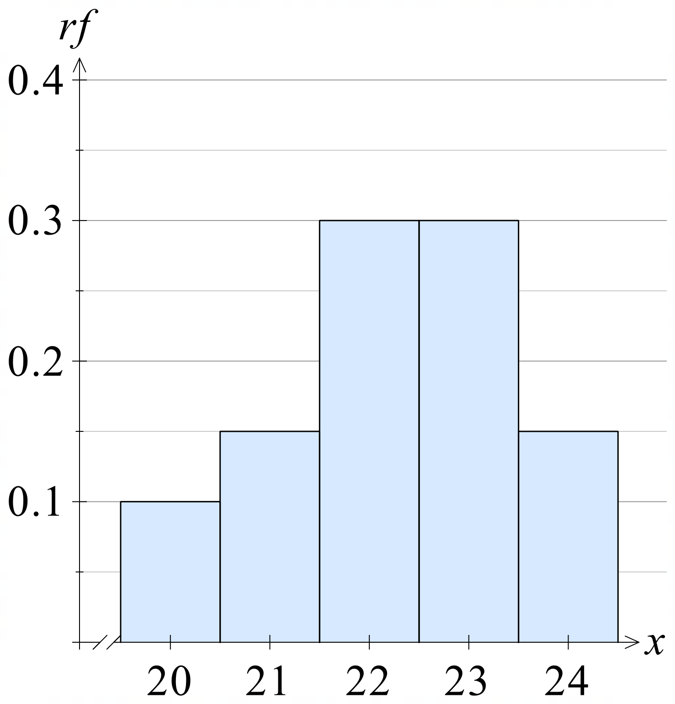
Given the table, calculate the relative frequencies and graph the result.
Outcome  $$x$$ | Frequency  $$f$$ | Relative Frequency  $$r.f.$$
20 | 4 | $$\frac{4}{40}=0.1$$
21 | 6 | $$\frac{6}{40}=0.15$$
22 | 12 | $$\frac{12}{40}=0.3$$
23 | 12 | $$\frac{12}{40}=0.3$$
24 | 6 | $$\frac{6}{40}=0.15$$
 | $Σf=$ 40 | $Σrf=$ 1

- Practice
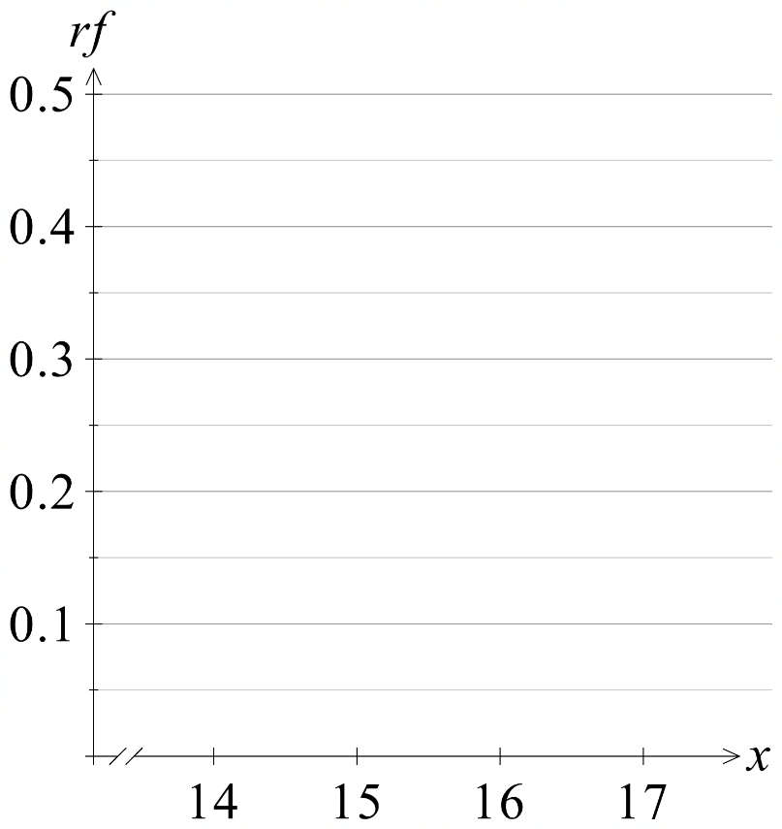
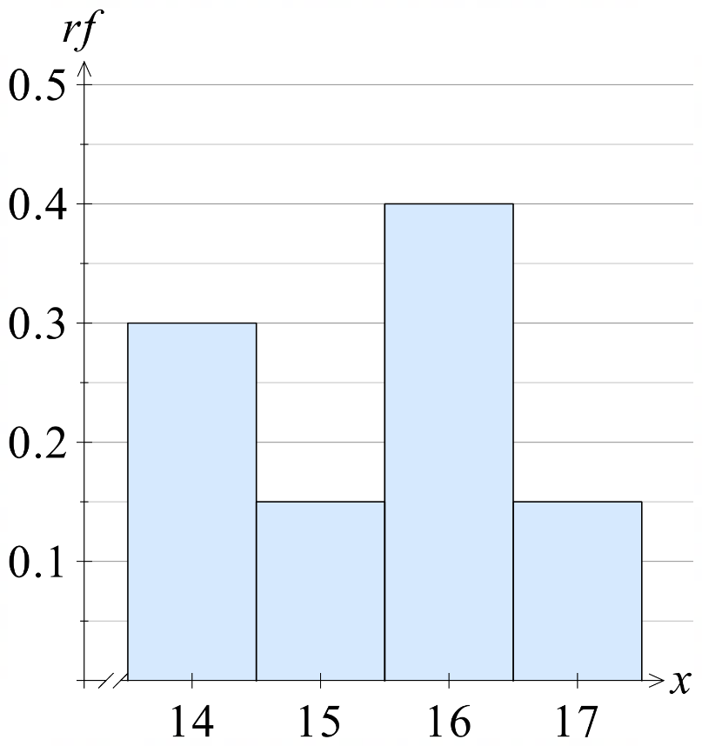
Given the table, calculate the relative frequencies and graph the result.
$$x$$ | $$f$$ | $$r.f.$$
14 | 6 | 0.3
15 | 3 | 0.15
16 | 8 | 0.4
17 | 3 | 0.15
 | $Σf=$ | $$Σrf=$$

- Investigation The Law of Large Numbers
A standard 6-sided die is rolled.
- List the set of possible outcomes: ……………………………
- What is the theoretical probability of each outcome? ……………………
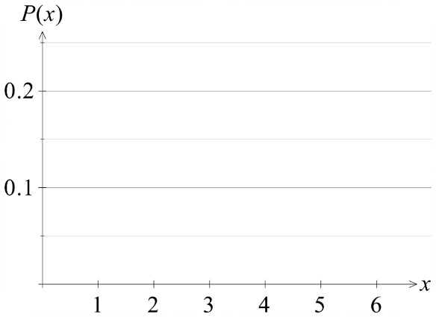
- Draw a histogram of the outcomes and their probabilities.

- What would you expect to happen if you roll a dice 6 times, according to the theoretical probabilities?

- https://mrdingmaths.github.io/LawofLargeNumbers/
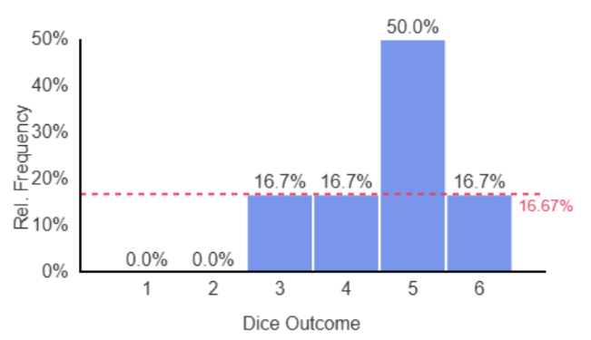  6 rolls | 100 rolls  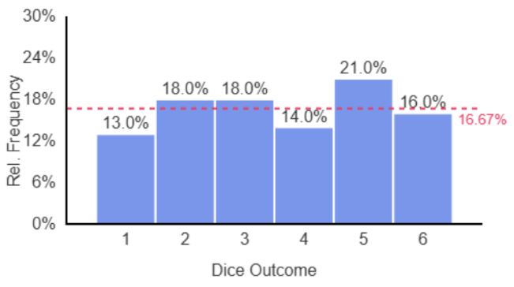
1000 rolls  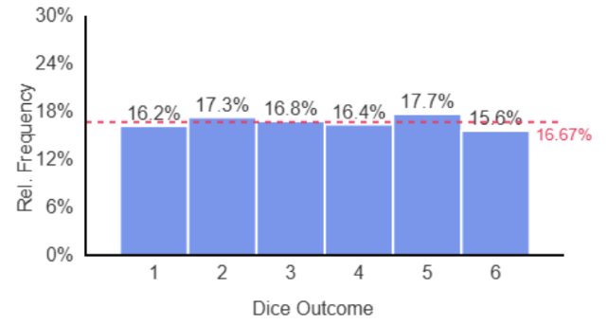 | 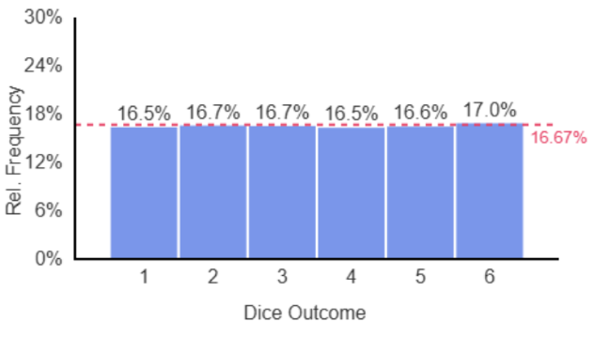  50000 rolls

- Law of Large Numbers
As number of trials increase, relative frequency approaches theoretical probability.

- Interpret The Law of Large Numbers
The result of a single random experiment is u……………………
With few trials, randomness means the relative frequency differs to the
t……………………… p…………………………
The Law of Large Numbers says that as you ………………… the number of trials, the relative frequency gets closer to the theoretical probability.
Therefore, if we don’t know the theoretical probability of an outcome, we can repeat an experiment many times and use the ……………… ………………… as an estimate for the theoretical probability. This is called observed probability.
The ……………… trials, the better the estimate.

- Experiment A: 10 coins are flipped.
Experiment B: 200 coins are flipped.
The relative frequency of getting heads and tails of each experiment is calculated.
Which survey would have relative frequency closest to the theoretical probability?
a | Experiment A | b | Experiment B | c | They would be the same. | d | Impossible to say.

- One day Nicole sees 6 cars pass her house. 2 of which are blue.
Nicole says: I estimate probability of seeing a blue car pass my house is $\frac{2}{6}$
How can she improve her estimate?
a | Simplify her fraction | b | Watch more cars and record her results | c | Find more blue cars | d | Go to a different house and repeat the observations

